Assignment is also being completed for C#

Reflection:
This semester I’m taking 4 classes, a 200-hour internship, and need to finish my capstone. Due to this, I think it’s important to plan out my days so that I can properly account for everything. Usually, I’m not very good at setting concrete times for all my different activities, so using previously made methods helped me a lot. It also helped with advice about the amount of time I should spend on each class to maximize productivity. Overall, I’m excited to see how this schedule works for me.

Completed Study Tool (study schedule):
Each screenshot shows 12 to 12.
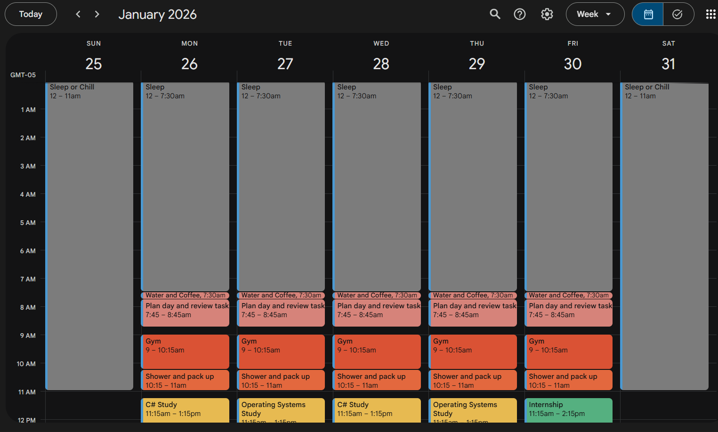
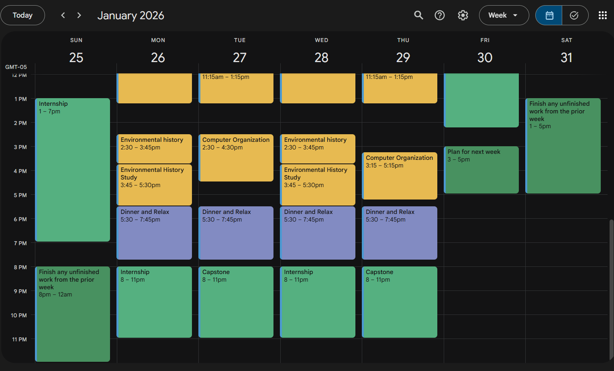

Prompt Screenshots:
